**August - October 2013**

Lebanon Regional FFA Chapter Newsletter

# MILKSHAKE BOOTH HUGE SUCCESS

Students sold milkshakes at the Lebanon Country Fair that was held on August 9th – 11th. Students were recruited during the summer by the chapter officers to work different shifts during the fair. Several students worked more than one shift as well as FFA graduates and Kathy Schultz to man the booth during the later hours. Thanks for everyone’s effort, we made $4,200 for the chapter.

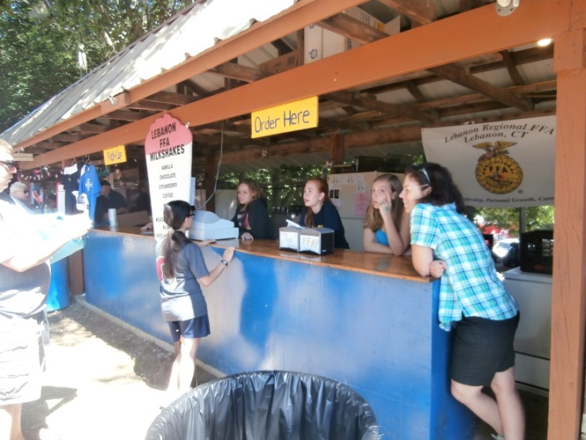

**Pictured**: left to right: Lauren Bauer (alum), Ingrid Bass, Lauren Pomerleau, Danielle Cone, Mrs. Schultz

## FRESHMAN PICNIC

Freshman Picnic has been and continues to be a great way for our Chapter Officers to get to know the freshmen and their families, and this year was no different. We played several games at the picnic including a kickball game between the officers and the freshmen, of which the freshman won. We also played a different version of “Would you rather?” asking questions like “Would you rather go to Tractor Supply or Cabela’s?”, as well as other important questions all good ag-ers should be able to answer. We completed the evening with a pot luck dinner with some delicious hot dogs and hamburgers, side salads, and dessert provided the officers. However, this event would not have been a success without our “grill man” Mr. Bauer who grilled for us again this year, thank you.

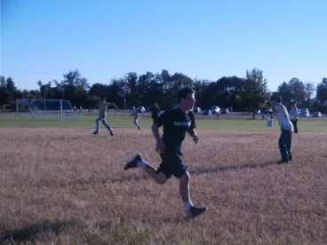

**Pictured**: Seth Hisman (freshmen)

## AG EXPO

Ag Expo is a time for students to exhibit their Supervised Agriculture Experience project. The Ag Expo was held on Wednesday, October 2nd. Some of the exhibits were ice cream making with Carly Dean and Reilly Lanagan, Bobwhite Quail with George Avery, Koi Ponds with Savannah Hoy, and Goat Milk Caramel with Kelsi Marks. Many dignitaries showed up like Senator Osten from Baltic, Linda Orange from Colchester, and Linda Finelli, Selectmen from Lebanon.

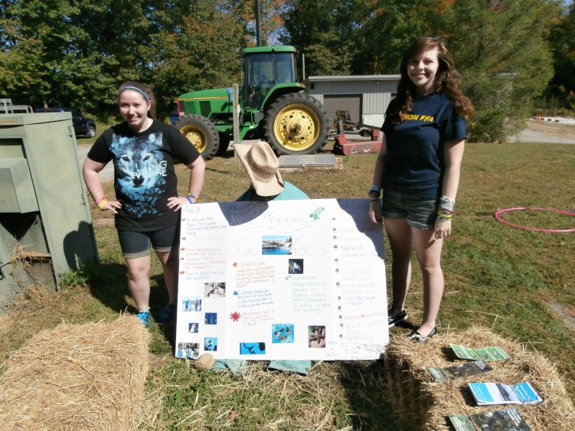

## Jr. Officers Selected for 2013-14

Congratulations to all the freshmen selected to be a junior officer this year. The following are their positions:

President: Maria Balderacchi

Vice President: Courtney Wildowsky

Secretary: Laura Smith

Tresurer: Olivia Drum

Reporter: Noah Chokas

Historian: Alicia Stepp

Parlimentarian: Lillian Barton

Sentinal: Abigail Christina

## COLT Conference

All of the officers attended the Chapter Officer Leadership Training on August 20th at Rockville High School; they learned many strategies and activities of which will be used throughout this school year.

## Lebanon Regional FFA Chapter is Louisville Bound

As many know every year near the end of October, The National FFA Organization sponsors the National FFA Convention. This year is no different as Louisville, Kentucky hosts the massive event that covers everything FFA related. There will be a concert by Dierks Bentley,a rodeo, a hyptomist show, an awards ceremony for the American Degree Candidates, CDE competitions and more. This event attracts approximately 55,000 FFA members dressed in the traditional national blue courduroy jackets of the FFA. The Lebanon Regional FFA Chapter is proud to have nine of the 19 American degree candidates from Connecticut. Graduates that are receiving the American Degree are: Emily Von Edwins, Grace Schultz, Dan Fields, David Johnston, Scarlett Abell, Michelle Shea, Brandon Smith, Rachel Mackewicz, and Heidi Rechlin. These students have achieved a milestone that roughly 0.025 % of the National FFA members receive in any given year.

In addition to Scarlett Abell receiving her American Degree, she is one of 200 National Proficiency Award Finalist out of 580,000 FFA members in the country this year. Scarlett has been a SAE proficiency award winner each year since her sophomore year and is now one of four finalist in the country for her Dairy Entrepreneurship SAE project. She will now compete with winners from Georgia, Ohio, and Wisconsin to be named a National Proficiency Award winner in Dairy Entrepreneurship. We wish her well in representing the Lebanon Regional FFA Chapter at the National FFA Convention.

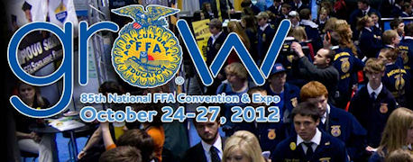

## FALL CDE’S ARE UNDERWAY

Career Development Events abbreviated CDE’s are fun activities that many FFA members take part in. From forestry to Ag Sales there is a wide range of CDE’s to suit everyone’s interest. All chapter members are encouraged to participate in one CDE at some time during their high school career. CDE’s are fun for all those who participate and CDE’s offer the opportunity for FFA members to learn something new, to add to their wealthy of knowledge. Though fall CDE teams have been decided there is still an opportunity to participate in a CDE this school year. Coming up are the winter CDE’s. For freshmen only there is a creed competition to recite the whole FFA creed, and open to every FFA member is the prepared and extemporaneous competitions. The winter CDE’s are a ton of fun so be sure to get in on the action and give a speech!

## Big E Provides A Fun Field Trip for Ag Members

Lebanon Regional FFA members attended the Big E in Springfield, MA on September 13th. Although our usual floral design booth was already taken by National FFA, several members volunteered their time to assist the National FFA staff to answer questions about FFA and sell FFA merchandise. In addition the students completed a picture Big E scavenger hunt while at the fair.

Scarlett Abell Wins Regional Star Farmer

The Lebanon Regional FFA Chapter was well represented at the Eastern Regional Star Farmer contest that was held at the Eastern States Exposition on September 14th during FFA Day. Scarlett was recognized as the Connecticut State Star Farmer at the CT FFA Convention in May, 2013 which gave her the opportunity to represent our state and chapter at the regional contest in September. At the regional contest she was interviewed by a panel of judges that had the hard job of selecting a regional winner from the 20 Eastern Regional States. The judges had commented that this was the hardest category they have ever had to judge which made Scarlett’s win even more impressive. Scarlett has had a very diversified SAE project throughout her FFA career with state winning proficiency awards in Ag Sales, Forage Production, Diversified Ag, and Dairy Entrepreneurship. The entire chapter wishes to congratulate her on her fine FFA career and with how well she represented our FFA Chapter. Written By Mrs. Wildes