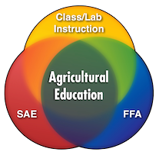
Ag Science Syllabus

HOW WILL I BE GRADED?

Quizzes/Projects: 40%
Class Participation: 30%
Assignments: 20%
Homework: 10%
OBJECTIVE
Agricultural education prepares students for successful careers and a lifetime of informed choices in the global agriculture, food, fiber and natural resources systems.

HOW IS CLASS PARTICIPATION GRADED?
You are expected to participate in class at all times and be attentive. Class participation grades are taken at random; they could be taken during a classroom activity or a laboratory exercise in the shop or outside. Getting a 100 for class participation is easy as long as you answer questions, help out, and are active. Lower grades are subjective to your participation.
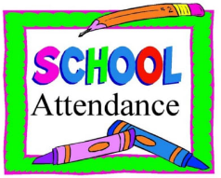
ATTENDANCE POLICY
When your absence from school is unavoidable, here are the basic procedures:
- Call a friend to obtain assignments or email me.
- Try to keep up with the work. You are in charge of your own education, so the initiative must be yours.
- If your absence is several days in length or longer, it is your responsibility to make the effort to obtain assignments. If you need help, you can call me or the main office to request that a friend of family member obtain assignments for you.
WILL I HAVE A LOT OF ASSIGNMENTS AND HOMEWORK IN YOUR CLASS?
Not a lot. However, when I do assign a project or homework, I expect it to be completed in a timely matter. Accepting late work is at my discretion. Generally, I subtract 10 points if it’s a day late. If you are absent from class for school excursions (field trip, concert, sports, etc.), you are NOT absent FROM SCHOOL. Therefore, you are responsible for handing in your assignments on time and/or consulting with me for any assignment given during the period you were on an excursion. IT IS YOUR RESPONSIBILITY TO CHECK WITH YOUR TEACHER FOR ANY ASSIGNMENTS MISSED DURING AN ABSENCE ASAP. Remember, the work of the class goes on, whether you are present or not.
How to get a hold of Mr. Picard

Geoffrey.picard@lebanonct.org

860-642-5739 (voicemail)
Tools for Success
-Be on time
-Always have a pen or pencil
-Bring a notebook
-Keep your Chromebook charged

